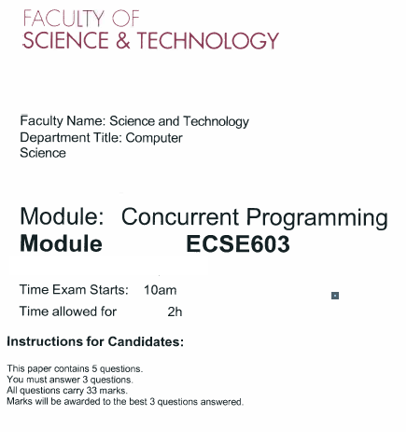

Question 1
- What is concurrent programming?
- Issues with concurrent programming?
Concurrency issues you found: Need to explain these issues with example race conditions and interference
- What are desired properties of concurrent programming (Safety properties & liveness properties, Deadlock, live lock differences)
Live lock – programme is running, but it doesn’t achieve the aim of the program
- Write a composite program to solve the problem of concurrency
    - Define 2 FSP code
    - Solve concurrent issues by modifying composite process
Process - Stage, Event
(Marks 19)
(Marks 33)

Question 2
Venn diagram
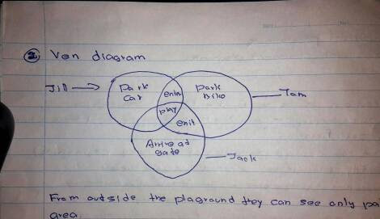
From outside the playground they can see only parking area
3 people Jack, Jill, Tom -> primitive process
Park car, park bike, arrive at gate are actions

- Write a primitive process for Jack, Tom, Jill
- Write a FSP for each primitive process
- Write process alphabet for all the actions of the composite process in the diagram
- Draw the trace tree for Jack
- Draw LTSA graph for Tom
- Briefly explain the following constructs used in FSP
    - Single pipe (|)
    - STOP
    - When (Boolean expression) – This is a guarded condition
    - -> explain the symbol (transition)
(Marks 33)

Question 3
- What are the 2 ways of implementing concurrent programming in java
(2014, 3, a)
- Write a concurrent java program which consists of 2 threads, the 1st thread prints numbers 1-100 and the 2nd thread the letters a-z. Start both threads. Explain what is happening.
(Marks 12)
- Modified the code you have written in previous question. So that the 2nd thread waits for the 1st thread to terminate before it begins the output.
(Marks 6)
- Modify the subsection (3), so that each thread sleeps for 1 second after printing a number or a letter. Explain the output.
Ex: Output cannot be determined.
(Marks 7)
(Marks 33)

Question 4
- Explain the word monitor with suitable example (refer lecture note 7 and 9)
Key words: encapsulating, controlled way, require in
Example code: write producer consumer code
- Compare CAR Hoare monitor concept with java monitor concepts.
Explain with suitable examples.
No need of a complete code. But you should include a class, a method, a shared variable, value for isAvailable variable and a while loop
(Marks 10)
- Implement the following requirements using the most suitable concurrent programming concepts
Case Study: house based husband and career minded wife
(Marks 33)

Question 5 - Semaphore
- What do you understand by the term semaphore?
Operations: claim(), acquire(), release()
- What are the different types of semaphores?
  - General semaphore
  - Binary semaphore
- What are the differences between 2 types of semaphores?
(use a table format)
- Write the code for semaphore using the producer consumer problem
(Marks 20)
(Marks 33)

